Date: 10/03/2022

Lab Session No.: 04

**Aim:**

Develop an android application to implement login and registration screen

**Software’s /IDE Tools:**

Android Development Kit / Android Studio

**Application User interface design:**

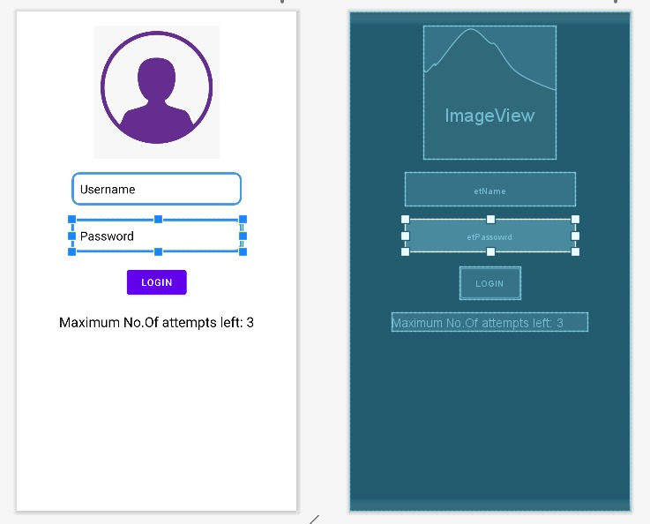

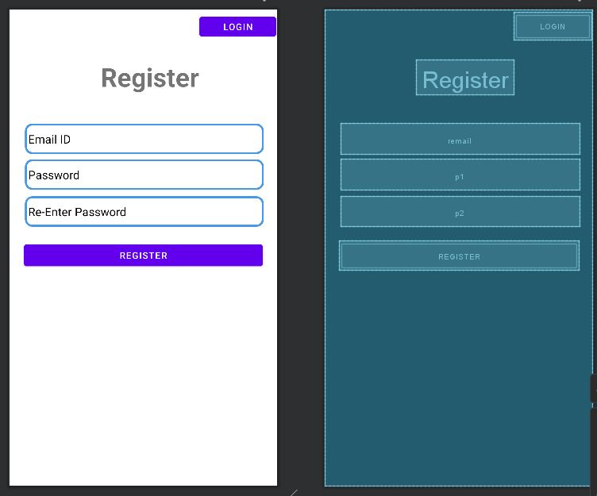

**Application Programming Interface:**

|  |  |  |  |
| --- | --- | --- | --- |
| **API / PACKAGES** | **CLASSES / INTERFACES** | **METHODS** | **DESCRIPTION** |
| import androidx.appcompat.app.AppCompatActivity; | AppCompatActivity | protected void onCreate(Bundle savedInstanceState) | onCreate(Bundle) is where you initialize your activity. When Activity is started and application is not loaded, then both onCreate() methods will be called. |
|  |  |
| import android.widget.EditText; | EditText | getText() | Determines the minimum type that getText() will return. If set, specifies that this TextView has a textual input method and should automatically capitalize what the user types. |

**Code/Implementation:**

// Develop an android application to demonstrate the Implicit and Explicit Intent.

// Project Name : ShareMyApp

/*

Lab Session No. : 04

Author : Tellakula Avinash

Date : 10/03/2022

Roll Number : 198W1A05C0

Description : login and registration page

Softwares required :Android Studio

Topics Covered :Implement login and registration page

*/

**LOGIN PAGE:**

**main_activity.java**

package com.avinash.loginform;

import androidx.appcompat.app.AppCompatActivity;

import android.content.Intent;

import android.os.Bundle;

import android.view.View;

import android.widget.Button;

import android.widget.EditText;

import android.widget.TextView;

public class MainActivity extends AppCompatActivity {

EditText name,password;

Button login;

TextView info;

int counter=3;

@Override

protected void onCreate(Bundle savedInstanceState) {

super.onCreate(savedInstanceState);

setContentView(R.layout.activity_main);

name=(EditText)findViewById(R.id.etName);

password=(EditText)findViewById(R.id.etPassowrd);

info=(TextView)findViewById(R.id.attempts);

login=(Button)findViewById(R.id.login);

info.setText("No. of Remaining Attempts : 3");

login.setOnClickListener(new View.OnClickListener() {

@Override

public void onClick(View v) {

validate(name.getText().toString(),password.getText().toString());

}

});

}

public void validate(String name, String password) {

if(name.equals("Admin") && password.equals("123#")){

Intent intent=new Intent(MainActivity.this,secondActivity.class);

startActivity(intent);

}

else{

counter--;

info.setText("No. of Remaining Attempts : "+counter);

if(counter==0){

login.setEnabled(false);

}

}

}

}

**activity_main.xml**

<?xml version="1.0" encoding="utf-8"?>

<LinearLayout xmlns:app="http://schemas.android.com/apk/res-auto"

xmlns:tools="http://schemas.android.com/tools"

xmlns:android="http://schemas.android.com/apk/res/android"

android:layout_width="match_parent"

android:layout_height="match_parent"

android:background="@color/white"

android:orientation="vertical"

android:layout_gravity="center"

tools:context=".MainActivity">

<ImageView

android:id="@+id/imageView2"

android:layout_width="194dp"

android:layout_height="195dp"

android:layout_gravity="center"

android:layout_marginTop="20dp"

app:srcCompat="@drawable/img" />

<EditText

android:id="@+id/etName"

android:layout_width="wrap_content"

android:layout_height="wrap_content"

android:layout_gravity="center"

android:width="250dp"

android:height="40dp"

android:hint="Username"

android:textColorHint="@color/black"

android:textColor="@color/black"

android:inputType="text"

android:minWidth="200dp"

android:layout_marginTop="20dp"

android:background="@drawable/edit_text_background1"

android:padding="12dp"/>

<EditText

android:id="@+id/etPassowrd"

android:layout_width="wrap_content"

android:layout_height="wrap_content"

android:layout_gravity="center"

android:width="250dp"

android:height="40dp"

android:textColor="@color/black"

android:textColorHint="@color/black"

android:hint="Password"

android:inputType="textPassword"

android:minWidth="200dp"

android:layout_marginTop="20dp"

android:background="@drawable/edit_text_background1"

android:padding="12dp"/>

<Button

android:id="@+id/login"

android:layout_width="wrap_content"

android:layout_height="wrap_content"

android:text="Login"

android:layout_gravity="center"

android:layout_marginTop="20dp"

tools:layout_editor_absoluteX="149dp"

tools:layout_editor_absoluteY="354dp" />

<TextView

android:id="@+id/attempts"

android:layout_width="wrap_content"

android:layout_height="wrap_content"

android:text="Maximum No.Of attempts left: 3"

android:textSize="20dp"

android:layout_marginTop="20dp"

android:layout_gravity="center"

android:textColor="@color/black"

android:autoSizeMaxTextSize="30sp"

tools:layout_editor_absoluteX="55dp"

tools:layout_editor_absoluteY="444dp" />

</LinearLayout>

**secondActivity.java**

package com.avinash.loginform;

import androidx.appcompat.app.AppCompatActivity;

import android.os.Bundle;

public class secondActivity extends AppCompatActivity {

@Override

protected void onCreate(Bundle savedInstanceState) {

super.onCreate(savedInstanceState);

setContentView(R.layout.activity_second);

}

}

**activity_second.xml**

<?xml version="1.0" encoding="utf-8"?>

<LinearLayout xmlns:android="http://schemas.android.com/apk/res/android"

xmlns:app="http://schemas.android.com/apk/res-auto"

xmlns:tools="http://schemas.android.com/tools"

android:layout_width="match_parent"

android:layout_height="match_parent"

tools:context=".secondActivity">

<TextView

android:id="@+id/attempts"

android:layout_width="wrap_content"

android:layout_height="wrap_content"

android:layout_gravity="center"

android:layout_marginTop="20dp"

android:autoSizeMaxTextSize="30sp"

android:paddingLeft="135dp"

android:text="Welcome"

android:textColor="@color/black"

android:textSize="40dp"

tools:layout_editor_absoluteX="55dp"

tools:layout_editor_absoluteY="444dp" />

</LinearLayout>

*edit_text_background1.xml*

<?xml version="1.0" encoding="utf-8"?>

<shape xmlns:android="http://schemas.android.com/apk/res/android"

android:shape="rectangle">

<stroke android:width="3dp"

android:color="#4799E4"/>

<corners android:radius="10dp"/>

<solid android:color="@color/white"/>

</shape>

**REGISTRATION PAGE:**

**MainActivity.java**

package com.avinash.register;  
  
import androidx.appcompat.app.AppCompatActivity;  
  
import android.content.Intent;  
import android.os.Bundle;  
import android.text.Editable;  
import android.view.View;  
import android.widget.Button;  
import android.widget.EditText;  
import android.widget.TextView;  
  
public class MainActivity extends AppCompatActivity {  
  
 @Override  
 protected void onCreate(Bundle savedInstanceState) {  
 super.onCreate(savedInstanceState);  
 setContentView(R.layout.*activity_main*);  
 String eo="admin@gmail.com";  
 String po="admin";  
 EditText email=(EditText)findViewById(R.id.*email*);  
 EditText pass=(EditText) findViewById(R.id.*pass*);  
 Button b=(Button)findViewById(R.id.*login*);  
 Button reg=(Button) findViewById(R.id.*reg*);  
 TextView t=(TextView) findViewById(R.id.*attempts*);  
 final int[] n = {3};  
 b.setOnClickListener(new View.OnClickListener() {  
  
 @Override  
 public void onClick(View v) {  
 Editable e=email.getText();  
 Editable p=pass.getText();  
 if(!String.*valueOf*(p).equals(po))  
 {  
 n[0]--;  
 if(n[0]==0)  
 {  
 b.setVisibility(View.*GONE*);  
 }  
 t.setText(String.*valueOf*(n[0])+" More attempts left...");  
 t.setVisibility(View.*VISIBLE*);  
 }  
  
 else  
 {  
 Intent intent=new Intent(MainActivity.this,SecondActivity.class);  
 startActivity(intent);  
  
 }  
  
 }  
 });  
 reg.setOnClickListener(new View.OnClickListener() {  
 @Override  
 public void onClick(View v) {  
 Intent regent=new Intent(MainActivity.this, RegisterActivity.class);  
 startActivity(regent);  
 }  
 });  
  
  
 }  
  
}

**activity_main.xml:**

*<?*xml version="1.0" encoding="utf-8"*?>*<androidx.constraintlayout.widget.ConstraintLayout xmlns:android="http://schemas.android.com/apk/res/android"  
 xmlns:app="http://schemas.android.com/apk/res-auto"  
 xmlns:tools="http://schemas.android.com/tools"  
 android:layout_width="match_parent"  
 android:layout_height="match_parent"  
 tools:context=".MainActivity">  
  
 <EditText  
 android:id="@+id/email"  
 android:layout_width="351dp"  
 android:layout_height="44dp"  
 android:background="@drawable/edit_text_background_1"  
 android:ems="10"  
 android:hint="E-mail ID"  
 android:textColorHint="@color/black"  
 android:textColor="@color/black"  
 android:inputType="textEmailAddress"  
 android:padding="10dp"  
 app:layout_constraintBottom_toBottomOf="parent"  
 app:layout_constraintEnd_toEndOf="parent"  
 app:layout_constraintHorizontal_bias="0.427"  
 app:layout_constraintStart_toStartOf="parent"  
 app:layout_constraintTop_toTopOf="parent"  
 app:layout_constraintVertical_bias="0.289" />  
  
 <EditText  
 android:id="@+id/pass"  
 android:textColorHint="@color/black"  
 android:textColor="@color/black"  
 android:layout_width="351dp"  
 android:layout_height="44dp"  
 android:background="@drawable/edit_text_background_1"  
 android:ems="10"  
 android:hint="Password"  
 android:inputType="textPassword"  
 android:padding="10dp"  
 app:layout_constraintBottom_toBottomOf="parent"  
 app:layout_constraintEnd_toEndOf="parent"  
 app:layout_constraintHorizontal_bias="0.388"  
 app:layout_constraintStart_toStartOf="parent"  
 app:layout_constraintTop_toBottomOf="@+id/email"  
 app:layout_constraintVertical_bias="0.029" />  
  
 <TextView  
 android:id="@+id/Label"  
 android:layout_width="133dp"  
 android:layout_height="75dp"  
 android:text="Login"  
 android:textSize="48sp"  
 app:layout_constraintBottom_toBottomOf="parent"  
 app:layout_constraintEnd_toEndOf="parent"  
 app:layout_constraintStart_toStartOf="parent"  
 app:layout_constraintTop_toTopOf="parent"  
 app:layout_constraintVertical_bias="0.042" />  
  
 <Button  
 android:id="@+id/login"  
 android:layout_width="351dp"  
 android:layout_height="44dp"  
 android:text="Login"  
 android:visibility="visible"  
 app:layout_constraintBottom_toBottomOf="parent"  
 app:layout_constraintEnd_toEndOf="parent"  
 app:layout_constraintHorizontal_bias="0.371"  
 app:layout_constraintStart_toStartOf="parent"  
 app:layout_constraintTop_toBottomOf="@+id/pass"  
 app:layout_constraintVertical_bias="0.038" />  
  
 <TextView  
 android:id="@+id/attempts"  
 android:layout_width="wrap_content"  
 android:layout_height="wrap_content"  
 android:text="3 More Attempts"  
 android:textSize="20dp"  
 android:visibility="invisible"  
 app:layout_constraintBottom_toBottomOf="parent"  
 app:layout_constraintEnd_toEndOf="parent"  
 app:layout_constraintHorizontal_bias="0.436"  
 app:layout_constraintStart_toStartOf="parent"  
 app:layout_constraintTop_toBottomOf="@+id/login"  
 app:layout_constraintVertical_bias="0.073" />  
  
 <Button  
 android:id="@+id/reg"  
 android:layout_width="wrap_content"  
 android:layout_height="wrap_content"  
 android:text="Register"  
 app:layout_constraintBottom_toTopOf="@+id/email"  
 app:layout_constraintEnd_toEndOf="parent"  
 app:layout_constraintHorizontal_bias="0.901"  
 app:layout_constraintStart_toEndOf="@+id/Label"  
 app:layout_constraintTop_toTopOf="parent"  
 app:layout_constraintVertical_bias="0.026" />  
  
</androidx.constraintlayout.widget.ConstraintLayout>

**SecondActivity.java:**

package com.avinash.register;  
  
import androidx.appcompat.app.AppCompatActivity;  
  
import android.os.Bundle;  
  
public class SecondActivity extends AppCompatActivity {  
 @Override  
 protected void onCreate(Bundle savedInstanceState) {  
 super.onCreate(savedInstanceState);  
 setContentView(R.layout.*activity_second*);  
 }  
}

**activity_second.xml:**

*<?*xml version="1.0" encoding="utf-8"*?>*<androidx.constraintlayout.widget.ConstraintLayout xmlns:android="http://schemas.android.com/apk/res/android"  
 xmlns:app="http://schemas.android.com/apk/res-auto"  
 xmlns:tools="http://schemas.android.com/tools"  
 android:layout_width="match_parent"  
 android:layout_height="match_parent"  
 tools:context=".SecondActivity">  
 <TextView  
 android:id="@+id/name"  
 android:layout_width="wrap_content"  
 android:layout_height="wrap_content"  
 android:text="Welcome User..."  
 android:textSize="34sp"  
 android:textStyle="bold"  
 app:layout_constraintBottom_toBottomOf="parent"  
 app:layout_constraintEnd_toEndOf="parent"  
 app:layout_constraintStart_toStartOf="parent"  
 app:layout_constraintTop_toTopOf="parent" />  
</androidx.constraintlayout.widget.ConstraintLayout>

**RegisterActivity.java:**

package com.avinash.register;  
  
import androidx.appcompat.app.AppCompatActivity;  
  
import android.content.Intent;  
import android.os.Bundle;  
import android.view.View;  
import android.widget.Button;  
import android.widget.EditText;  
import android.widget.Toast;  
  
public class RegisterActivity extends AppCompatActivity {  
  
 EditText email,p1,p2;  
 Button reg,log;  
 @Override  
 protected void onCreate(Bundle savedInstanceState) {  
 super.onCreate(savedInstanceState);  
 setContentView(R.layout.*activity_register*);  
  
 email=(EditText) findViewById(R.id.*email*);  
 p1=(EditText) findViewById(R.id.*p1*);  
 p2=(EditText) findViewById(R.id.*p2*);  
 reg=(Button) findViewById(R.id.*register*);  
 log=(Button) findViewById(R.id.*rlogin*);  
 reg.setOnClickListener(new View.OnClickListener() {  
 @Override  
 public void onClick(View v) {  
 String pass1,pass2;  
 pass1=String.*valueOf*(p1.getText());  
 pass2=String.*valueOf*(p2.getText());  
  
 if(pass1.equals(pass2))  
 {  
 Intent login=new Intent(RegisterActivity.this,SecondActivity.class);  
 System.*out*.println("Matched");  
 startActivity(login);  
 }  
 else  
 {  
 Toast.*makeText*(getApplicationContext(),"Password Mismatch...",Toast.*LENGTH_LONG*).show();  
 System.*out*.println("Not Matched");  
 }  
 }  
 });  
  
 log.setOnClickListener(new View.OnClickListener() {  
 @Override  
 public void onClick(View v) {  
 Intent login=new Intent(RegisterActivity.this,MainActivity.class);  
 System.*out*.println("Login Page|RegisterActivity");  
 startActivity(login);  
 }  
 });  
 }  
  
  
}

**activity_register.xml:**

*<?*xml version="1.0" encoding="utf-8"*?>*<androidx.constraintlayout.widget.ConstraintLayout xmlns:android="http://schemas.android.com/apk/res/android"  
 xmlns:app="http://schemas.android.com/apk/res-auto"  
 xmlns:tools="http://schemas.android.com/tools"  
 android:layout_width="match_parent"  
 android:layout_height="match_parent"  
 tools:context=".RegisterActivity">  
 <TextView  
 android:id="@+id/textView"  
 android:layout_width="wrap_content"  
 android:layout_height="wrap_content"  
 android:text="Register"  
 android:textAlignment="center"  
 android:textSize="40dp"  
 android:textStyle="bold"  
 app:layout_constraintBottom_toBottomOf="parent"  
 app:layout_constraintEnd_toEndOf="parent"  
 app:layout_constraintHorizontal_bias="0.538"  
 app:layout_constraintStart_toStartOf="parent"  
 app:layout_constraintTop_toTopOf="parent"  
 app:layout_constraintVertical_bias="0.113" />  
  
 <EditText  
 android:id="@+id/remail"  
 android:layout_width="367dp"  
 android:layout_height="47dp"  
 android:ems="10"  
 android:textColorHint="@color/black"  
 android:textColor="@color/black"  
 android:hint="Email ID"  
 android:inputType="textPersonName"  
 app:layout_constraintBottom_toBottomOf="parent"  
 app:layout_constraintEnd_toEndOf="parent"  
 app:layout_constraintHorizontal_bias="0.527"  
 app:layout_constraintStart_toStartOf="parent"  
 app:layout_constraintTop_toTopOf="parent"  
 app:layout_constraintVertical_bias="0.256"  
 android:background="@drawable/edit_text_background_1"  
 android:paddingLeft="5dp"/>  
  
 <EditText  
 android:id="@+id/p1"  
 android:layout_width="367dp"  
 android:layout_height="47dp"  
 android:ems="10"  
 android:hint="Password"  
 android:inputType="textPassword"  
 android:textColorHint="@color/black"  
 app:layout_constraintBottom_toBottomOf="parent"  
 app:layout_constraintEnd_toEndOf="parent"  
 app:layout_constraintHorizontal_bias="0.527"  
 app:layout_constraintStart_toStartOf="parent"  
 app:layout_constraintTop_toBottomOf="@+id/remail"  
 app:layout_constraintVertical_bias="0.017"  
 android:textColor="@color/black"  
 android:background="@drawable/edit_text_background_1"  
 android:paddingLeft="5dp"/>  
  
 <EditText  
 android:id="@+id/p2"  
 android:layout_width="367dp"  
 android:layout_height="47dp"  
 android:ems="10"  
 android:textColorHint="@color/black"  
 android:hint="Re-Enter Password"  
 android:inputType="textPassword"  
 android:textColor="@color/black"  
 app:layout_constraintBottom_toBottomOf="parent"  
 app:layout_constraintEnd_toEndOf="parent"  
 app:layout_constraintHorizontal_bias="0.527"  
 app:layout_constraintStart_toStartOf="parent"  
 app:layout_constraintTop_toBottomOf="@+id/p1"  
 app:layout_constraintVertical_bias="0.024"  
 android:background="@drawable/edit_text_background_1"  
 android:paddingLeft="5dp"/>  
  
 <Button  
 android:id="@+id/register"  
 android:layout_width="367dp"  
 android:layout_height="45dp"  
 android:text="register"  
 app:layout_constraintBottom_toBottomOf="parent"  
 app:layout_constraintEnd_toEndOf="parent"  
 app:layout_constraintHorizontal_bias="0.498"  
 app:layout_constraintStart_toStartOf="parent"  
 app:layout_constraintTop_toBottomOf="@+id/p2"  
 app:layout_constraintVertical_bias="0.061" />  
  
 <Button  
 android:id="@+id/rlogin"  
 android:layout_width="118dp"  
 android:layout_height="42dp"  
 android:text="login"  
 app:layout_constraintBottom_toBottomOf="parent"  
 app:layout_constraintEnd_toEndOf="parent"  
 app:layout_constraintHorizontal_bias="0.993"  
 app:layout_constraintStart_toStartOf="parent"  
 app:layout_constraintTop_toTopOf="parent"  
 app:layout_constraintVertical_bias="0.008" />  
</androidx.constraintlayout.widget.ConstraintLayout>

**Output: LOGIN FORM**

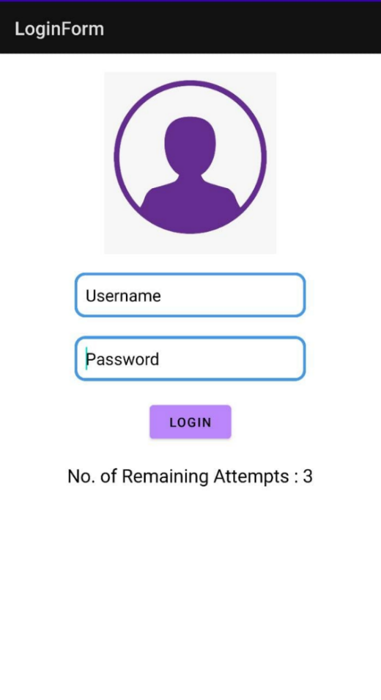 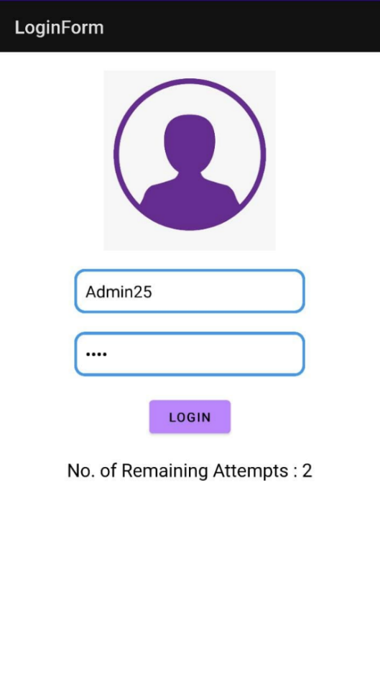 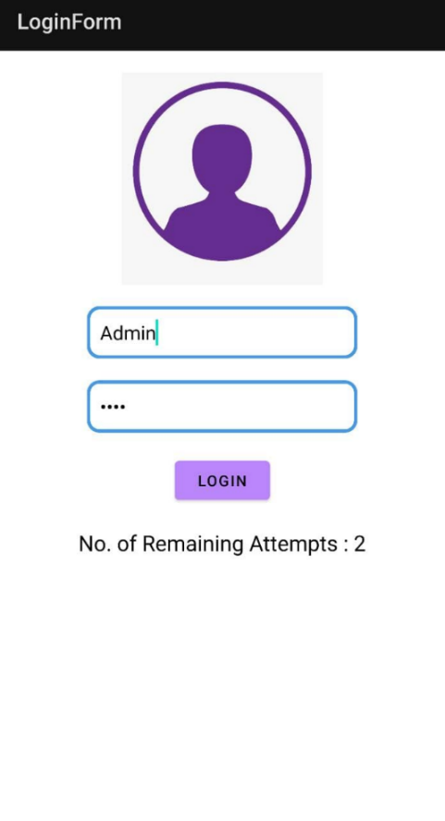 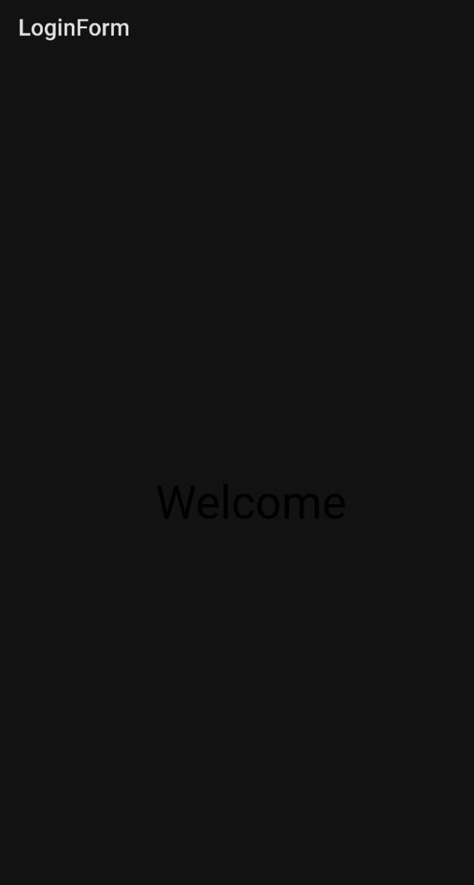

**REGISTRATION FORM:**

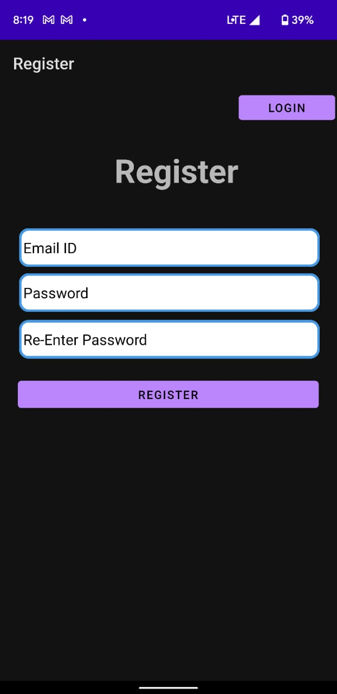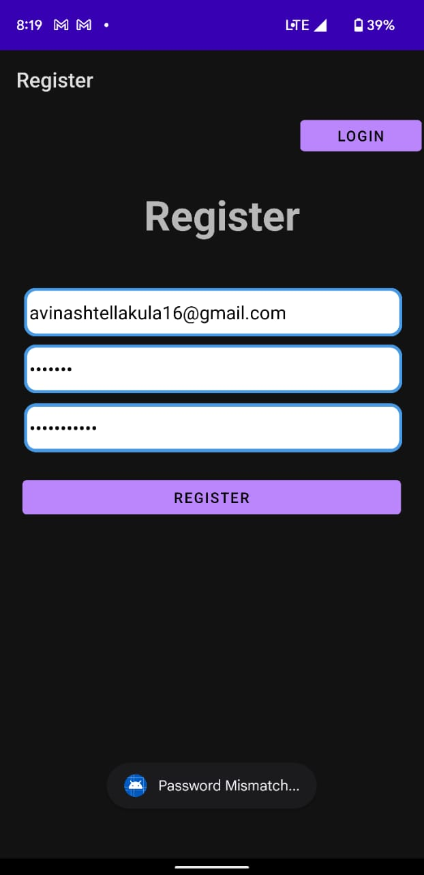

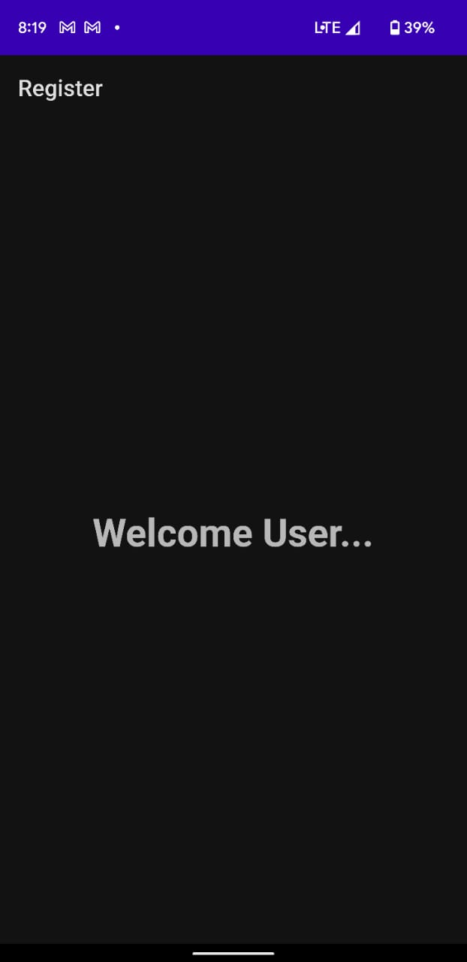

**Result:**

Demonstration of the Login and Registration were done successfully.